WEEK 7 :React

File 10. ReactJS HandsOn
OfficeSpace.js
import React from 'react';
const OfficeSpace = () => {
const heading = <h1 style={{ textAlign: 'center' }}>Office Space Rental</h1>;
const officeList = [
{
name: 'WeWork',
rent: 50000,
address: 'Koramangala, Bangalore',
image: 'https://via.placeholder.com/200x100?text=WeWork'
},
{
name: 'SmartSpace',
rent: 75000,
address: 'Hitech City, Hyderabad',
image: 'https://via.placeholder.com/200x100?text=SmartSpace'
},
{
name: 'Cowork Hub',
rent: 60000,
address: 'T. Nagar, Chennai',
image: 'https://via.placeholder.com/200x100?text=Cowork+Hub'
}
];
return (
<div>
{heading}
<div style={{ display: 'flex', gap: '20px', justifyContent: 'center', flexWrap: 'wrap' }}>
{officeList.map((office, index) => (
<div key={index} style={{ border: '1px solid gray', padding: '10px', width: '250px' }}>
<img src={office.image} alt={office.name} style={{ width: '100%' }} />
<h3>{office.name}</h3>
<p style={{ color: office.rent < 60000 ? 'red' : 'green' }}>
Rent: ₹{office.rent}
</p>
<p>{office.address}</p>
</div>
))}
</div>
</div>
);
};

export default OfficeSpace;
App.js
import React from 'react';
import OfficeSpace from './OfficeSpace';
function App() {
return (
<div className="App">
<OfficeSpace />
</div>
);
}
export default App;
Output:

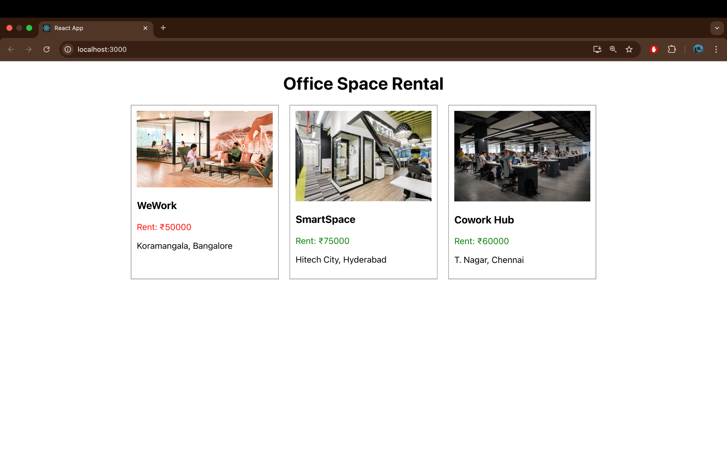

File 11.ReactJS HandsOn
EventExamples.js

import React, { Component } from 'react';
class EventExamples extends Component {
constructor(props) {
super(props);
this.state = {
count: 0
};
}

increment = () => {
this.setState({ count: this.state.count + 1 });
this.sayHello();
};

decrement = () => {
this.setState({ count: this.state.count - 1 });
};

sayHello = () => {
alert("Hello! This is a static message.");
};

sayWelcome = (message) => {
alert(message);
};

handleClick = (event) => {
alert("I was clicked"); // Synthetic event
};

render() {
return (
<div style={{ textAlign: 'center', marginTop: '30px' }}>
<h2>Event Handling Example</h2>
<p>Counter: {this.state.count}</p>
<button onClick={this.increment}>Increase</button>
<button onClick={this.decrement} style={{ marginLeft: '10px' }}>Decrease</button>
<br /><br />
<button onClick={() => this.sayWelcome("Welcome!")}>Say Welcome</button>
<br /><br />
<button onClick={this.handleClick}>Click Me (Synthetic Event)</button>
</div>
);
}
}
export default EventExamples;
CurrencyConvertor.js

import React, { useState } from 'react';
const CurrencyConvertor = () => {
const [rupees, setRupees] = useState('');
const [euro, setEuro] = useState('');
const handleSubmit = () => {
const conversionRate = 0.011; // 1 INR = 0.011 Euro (approx)
const result = parseFloat(rupees) * conversionRate;
setEuro(result.toFixed(2));
};
return (
<div style={{ textAlign: 'center', marginTop: '30px' }}>
<h2>Currency Convertor</h2>
<input
type="number"
placeholder="Enter amount in INR"
value={rupees}
onChange={(e) => setRupees(e.target.value)}
/>
<button onClick={handleSubmit} style={{ marginLeft: '10px' }}>Convert</button>
<p>Euro: €{euro}</p>
</div>
);
};
export default CurrencyConvertor;
import React from 'react';
import EventExamples from './EventExamples';
import CurrencyConvertor from './CurrencyConvertor';
function App() {
return (
<div className="App">
<EventExamples />
<CurrencyConvertor />
</div>
);
}
export default App;

Output:
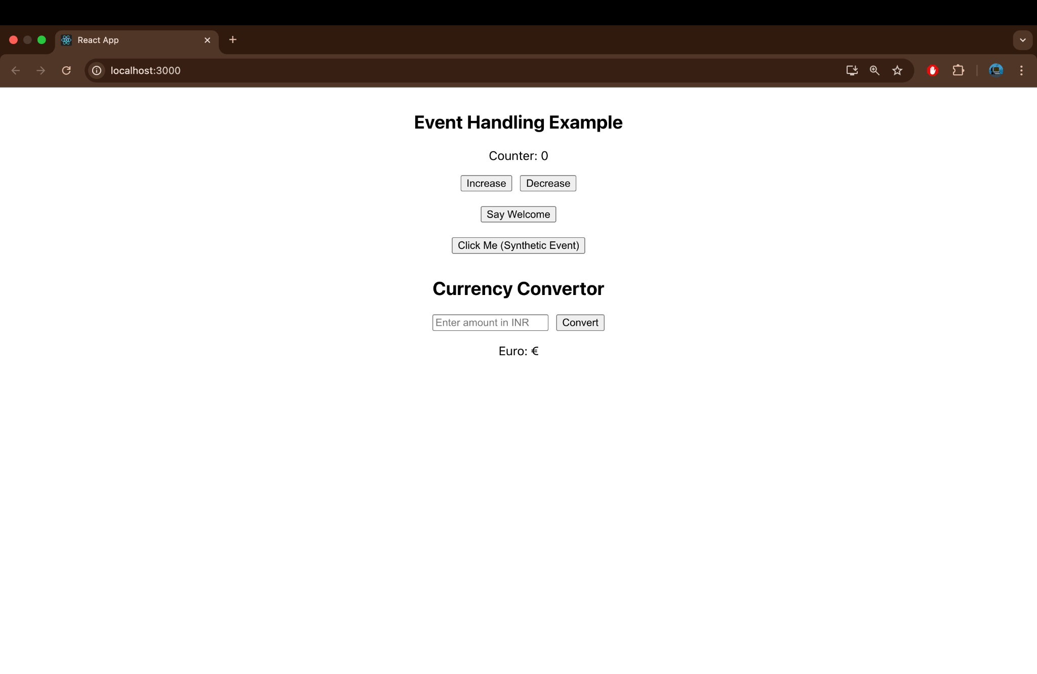

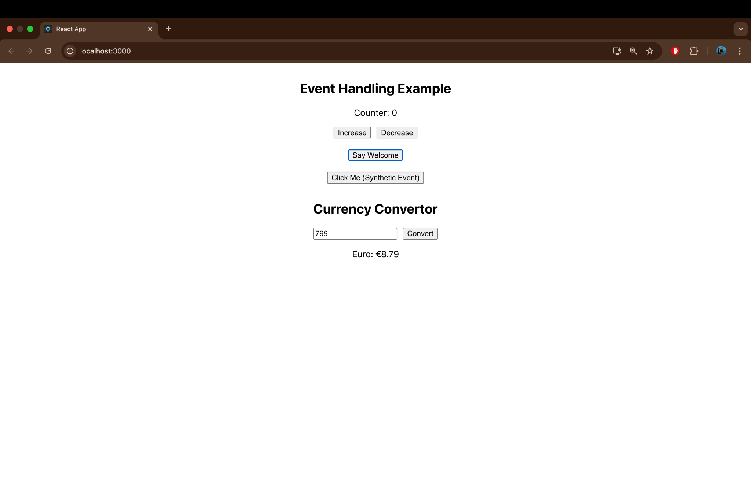

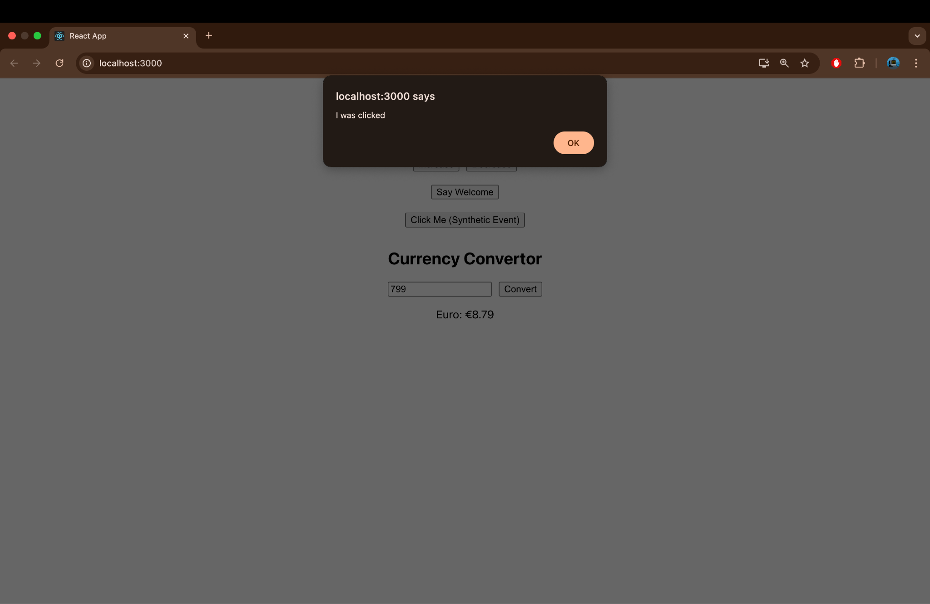

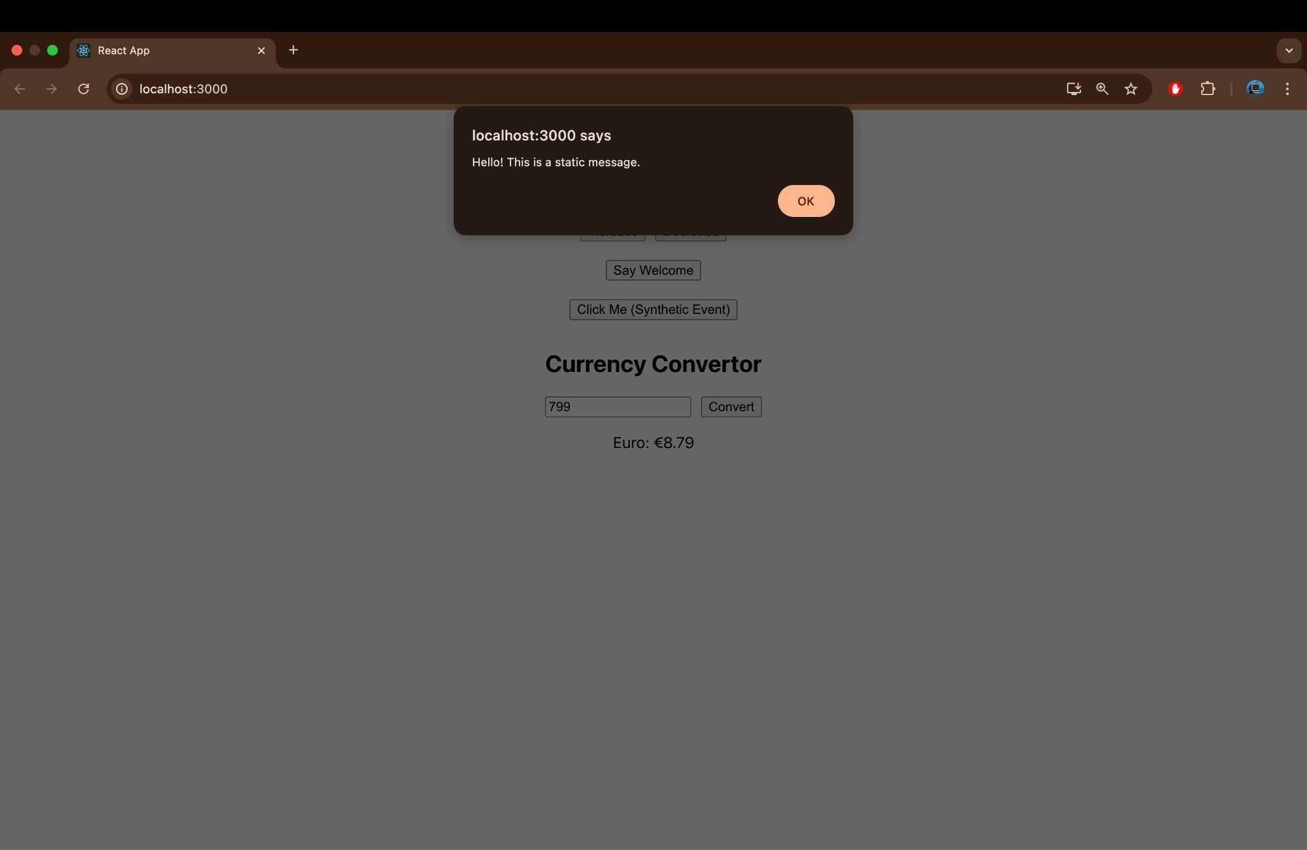

File 12. ReactJS HandsOn
// GuestPage.js
import React from 'react';
const GuestPage = () => {
return (
<div style={{ textAlign: 'center' }}>
<h2>Welcome Guest!</h2>
<p>You can browse the available flights, but must log in to book.</p>
</div>
);
};
export default GuestPage;

// UserPage.js
import React from 'react';
const UserPage = () => {
return (
<div style={{ textAlign: 'center' }}>
<h2>Welcome Back!</h2>
<p>You can now book tickets for available flights.</p>
</div>
);
};
export default UserPage;
App.css
body {
margin: 0;
font-family: Arial, sans-serif;
background-color: #f4f4f4;
}

.app-container {
text-align: center;
padding: 40px;
min-height: 100vh;
}

.card {
background: white;
padding: 30px;
margin: 30px auto;
width: 60%;
border-radius: 12px;
box-shadow: 0 4px 10px rgba(0, 0, 0, 0.1);
}
.app-button {
padding: 10px 20px;
font-size: 16px;
border-radius: 6px;
border: none;
cursor: pointer;
color: white;
}
.login-button {
background-color: #5cb85c;
}
.logout-button {
background-color: #d9534f;
}
App.js
import React, { useState } from 'react';
import GuestPage from './GuestPage';
import UserPage from './UserPage';
import './App.css';
function App() {
const [isLoggedIn, setIsLoggedIn] = useState(false);
const handleLogin = () => {
setIsLoggedIn(true);
};
const handleLogout = () => {
setIsLoggedIn(false);
};
let pageContent;
if (isLoggedIn) {
pageContent = <UserPage />;
} else {
pageContent = <GuestPage />;
}
return (
<div className="app-container">
<div className="card">
<h1>✈️ Ticket Booking App</h1>
<button
className={`app-button ${isLoggedIn ? 'logout-button' : 'login-button'}`}
onClick={isLoggedIn ? handleLogout : handleLogin}
>
{isLoggedIn ? 'Logout' : 'Login'}
</button>
<hr />
{pageContent}
</div>
</div>
);
export default App;
Output:

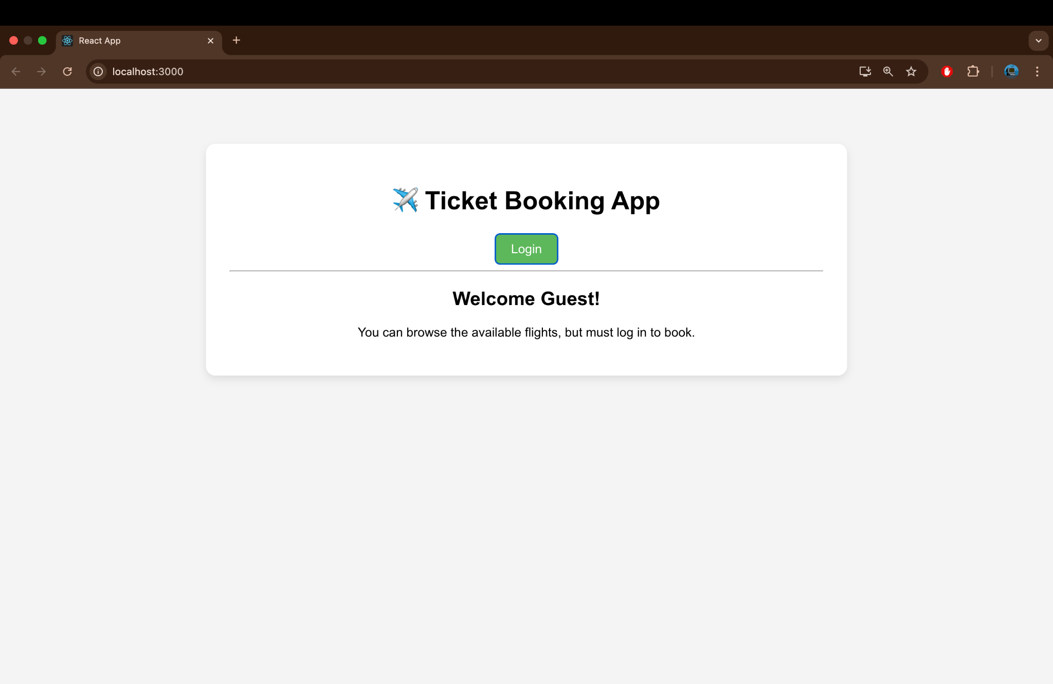

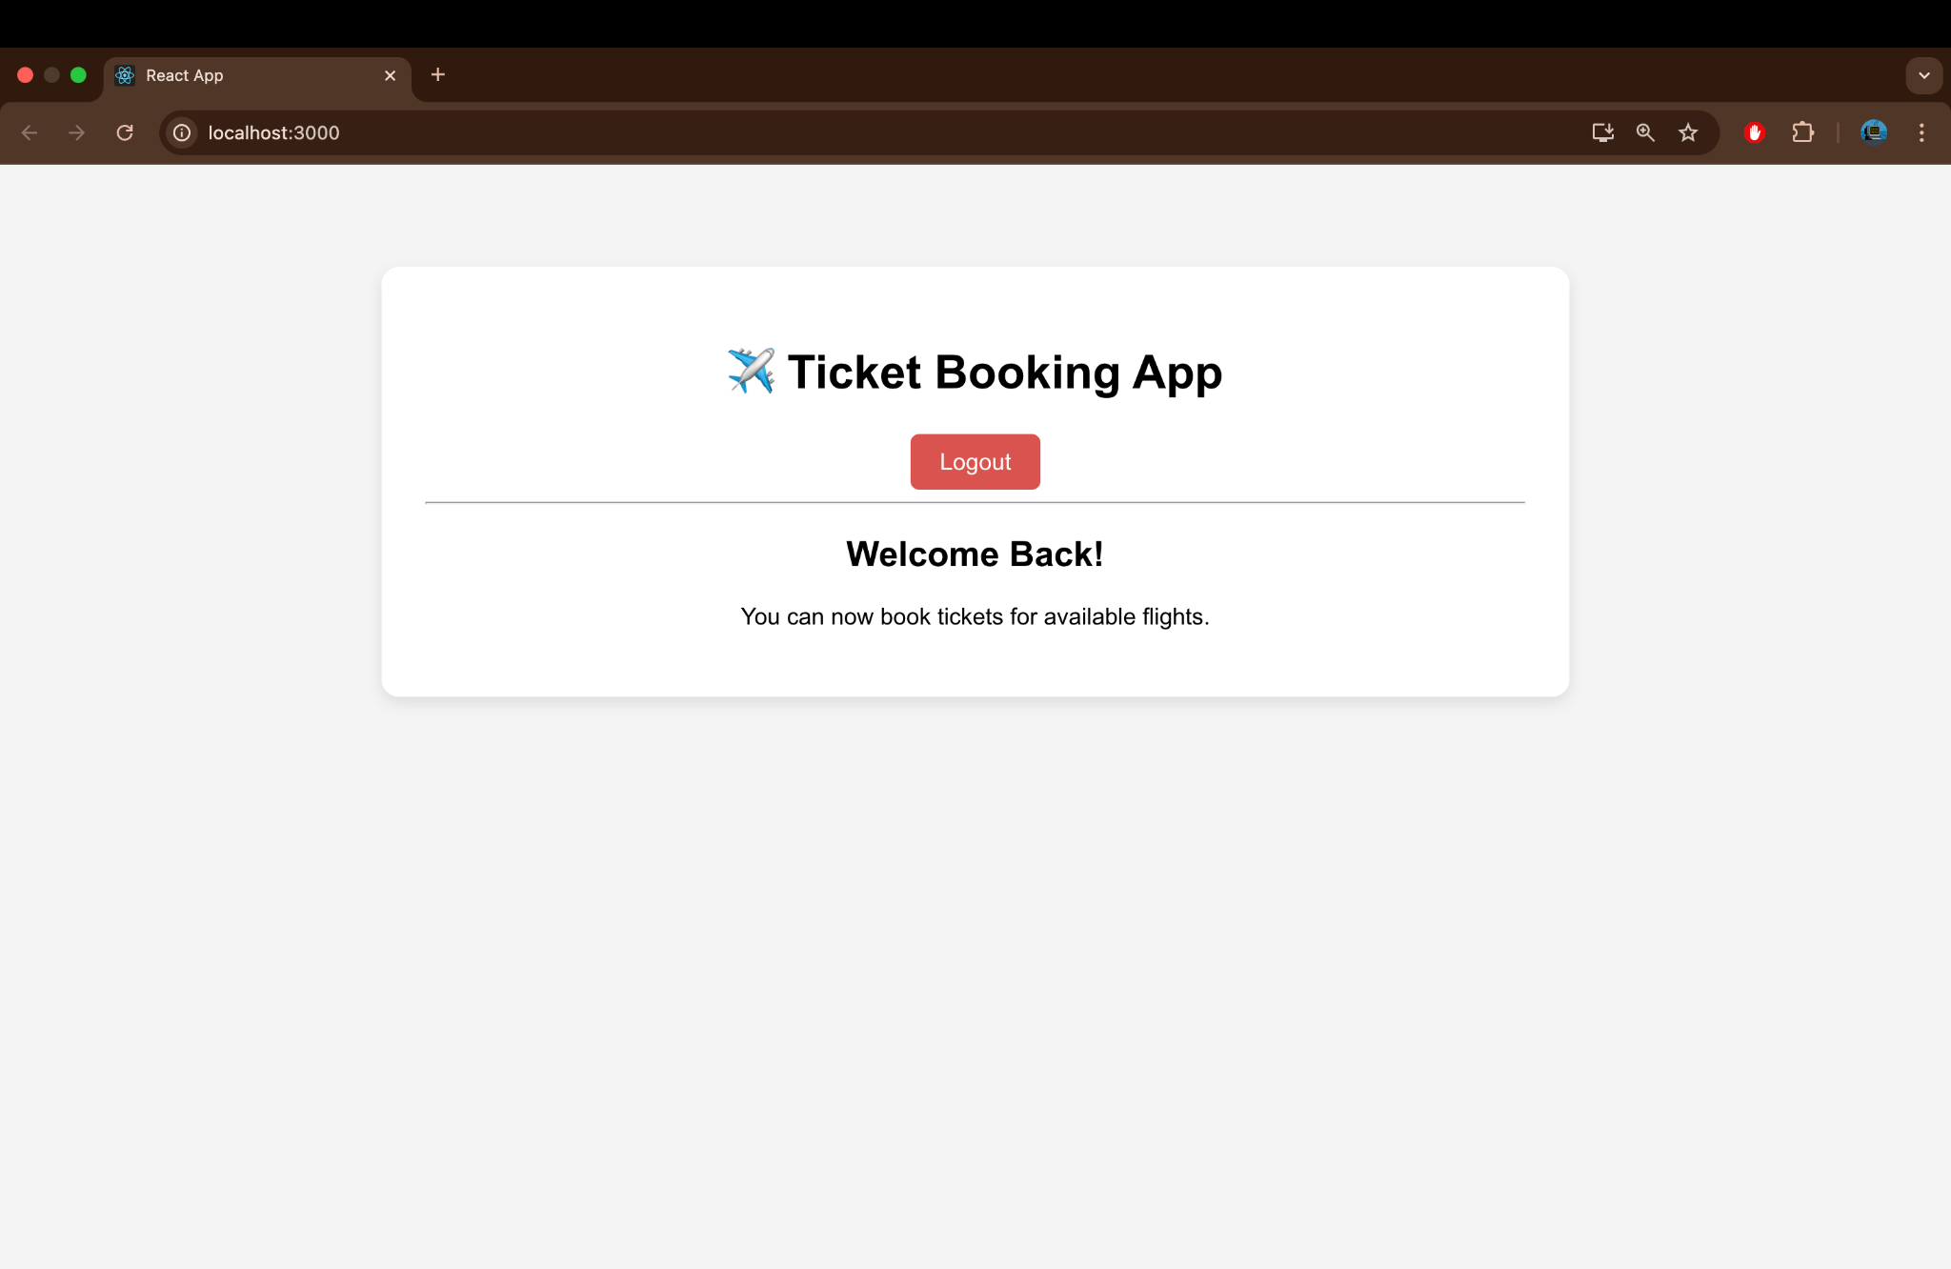

File 13:ReactJS Handson
import React from 'react';
function BookDetails() {
return (
<div>
<h3> Book Details</h3>
<ul>
<li><strong>Title:</strong> React Explained</li>
<li><strong>Author:</strong> Zac Gordon</li>
<li><strong>Published:</strong> 2023</li>
<li><strong>Price:</strong> ₹799</li>
</ul>
</div>
);
}
export default BookDetails;

import React from 'react';
function BlogDetails() {
return (
<div>
<h3>Blog Details</h3>
<ul>
<li><strong>Title:</strong> Mastering React Components</li>
<li><strong>Author:</strong> Keerthi SV</li>
<li><strong>Date:</strong> July 14, 2025</li>
<li><strong>Category:</strong> Frontend Development</li>
</ul>
</div>
);
}
export default BlogDetails;

import React from 'react';
function CourseDetails() {
return (
<div>
<h3> Course Details</h3>
<ul>
<li><strong>Course Name:</strong> React Fullstack Development</li>
<li><strong>Duration:</strong> 6 Weeks</li>
<li><strong>Mode:</strong> Online (Self-paced)</li>
<li><strong>Instructor:</strong> S V Keerthi</li>
</ul>
</div>
);
}

export default CourseDetails;
App.js
import React, { useState } from 'react';
import BookDetails from './BookDetails';
import BlogDetails from './BlogDetails';
import CourseDetails from './CourseDetails';

function App() {
const [active, setActive] = useState('book');
return (
<div style={{ padding: '20px' }}>
<h2>Blogger App Dashboard</h2>
<button onClick={() => setActive('book')}>Show Book</button>
<button onClick={() => setActive('blog')}>Show Blog</button>
<button onClick={() => setActive('course')}>Show Course</button>

<hr />
{/* 1. if-else using ternary */}
{active === 'book' ? <BookDetails /> : null}

{/* 2. logical && operator */}
{active === 'blog' && <BlogDetails />}

{/* 3. conditional function */}
{(() => {
if (active === 'course') {
return <CourseDetails />;
}
})()}
</div>
);
}

export default App;

Output:
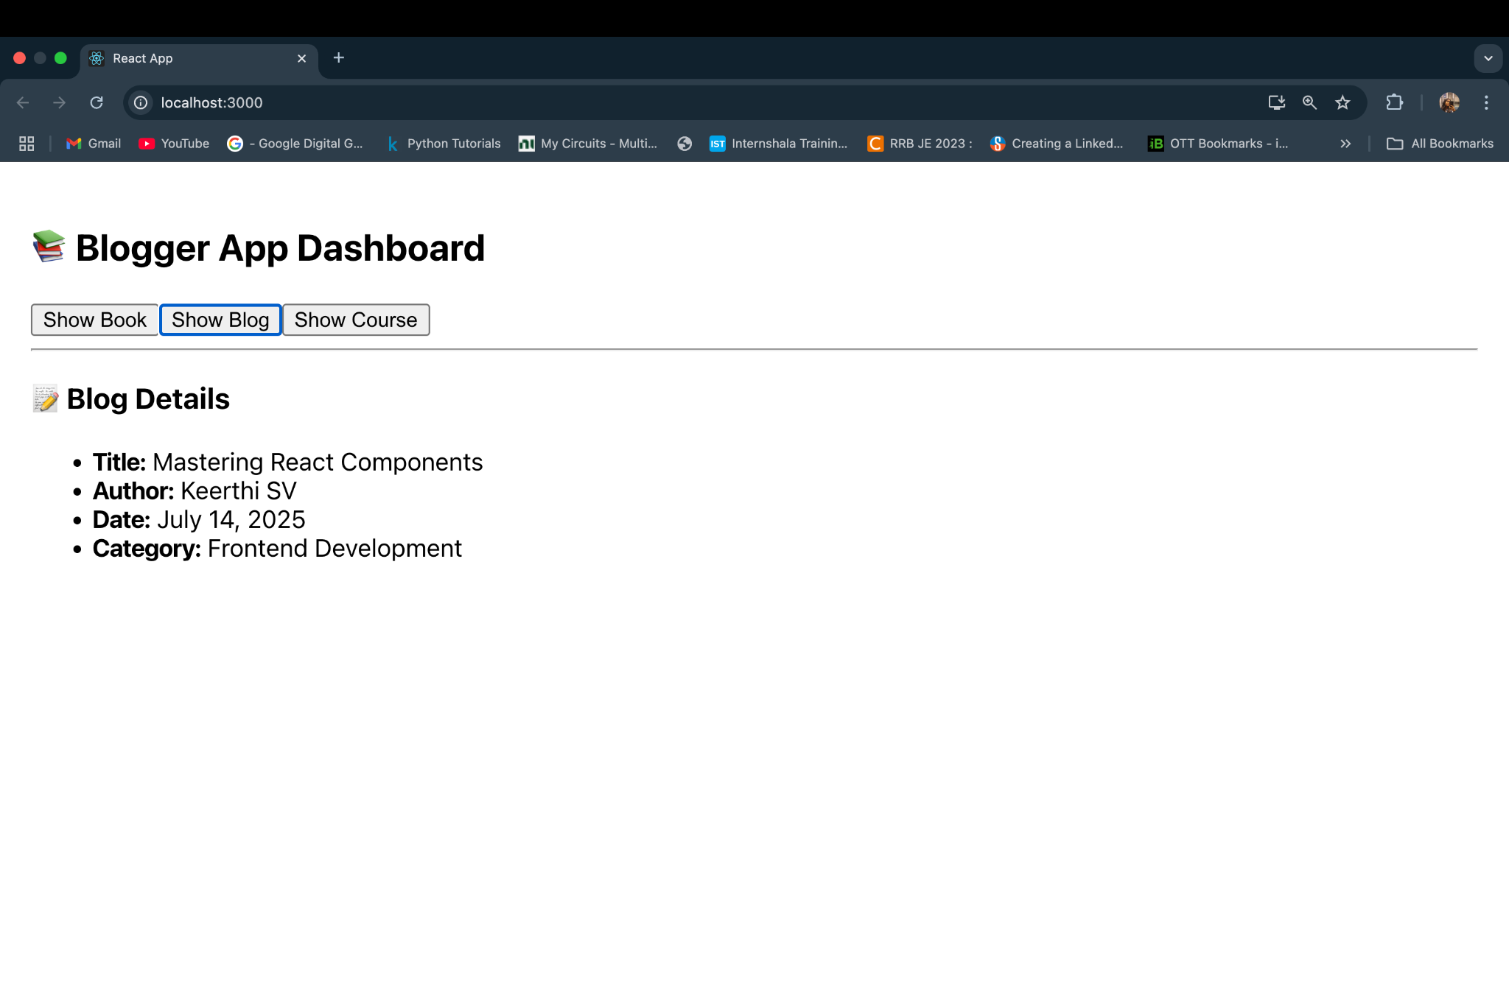

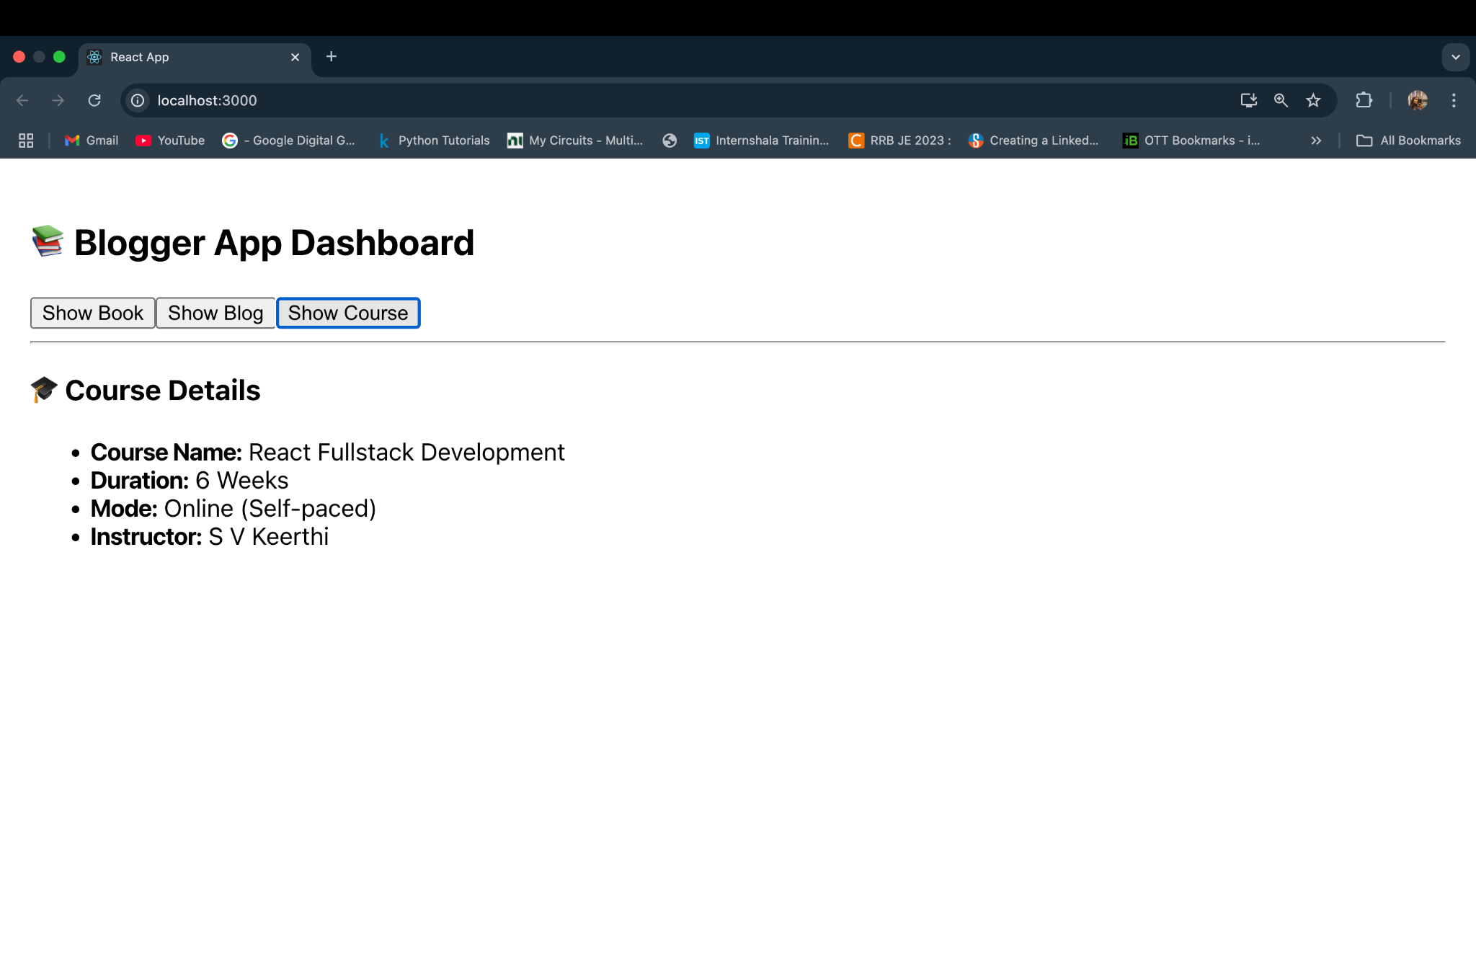

File 14: ReactJS Handson

import React from 'react';
const ThemeContext = React.createContext('light');

export default ThemeContext;
import React, { useContext } from 'react';
import ThemeContext from './ThemeContext';

function EmployeeCard({ name, role }) {
const theme = useContext(ThemeContext);

const buttonStyle = {
backgroundColor: theme === 'dark' ? '#333' : '#ddd',
color: theme === 'dark' ? '#fff' : '#000',
padding: '10px 20px',
border: 'none',
marginTop: '10px',
cursor: 'pointer',
};

return (
<div style={{ border: '1px solid gray', margin: '10px', padding: '10px' }}>
<h4>{name}</h4>
<p>Role: {role}</p>
<button style={buttonStyle}>Contact</button>
</div>
);
}

export default EmployeeCard;

import React from 'react';
import EmployeeCard from './EmployeeCard';

function EmployeeList() {
const employees = [
{ id: 1, name: 'Alice', role: 'Developer' },
{ id: 2, name: 'Bob', role: 'Designer' },
{ id: 3, name: 'Charlie', role: 'Tester' },
];

return (
<div>
<h3>Employee List</h3>
{employees.map(emp => (
<EmployeeCard key={emp.id} name={emp.name} role={emp.role} />
))}
</div>
);
}

export default EmployeeList;

import React, { useState } from 'react';
import ThemeContext from './ThemeContext';
import EmployeeList from './EmployeeList';

function App() {
const [theme, setTheme] = useState('light');

return (
<ThemeContext.Provider value={theme}>
<div style={{ padding: '20px' }}>
<h2>Employee Management App</h2>

<button onClick={() => setTheme(prev => prev === 'light' ? 'dark' : 'light')}>
Toggle Theme
</button>

<EmployeeList />
</div>
</ThemeContext.Provider>
);
}

export default App;

Output:
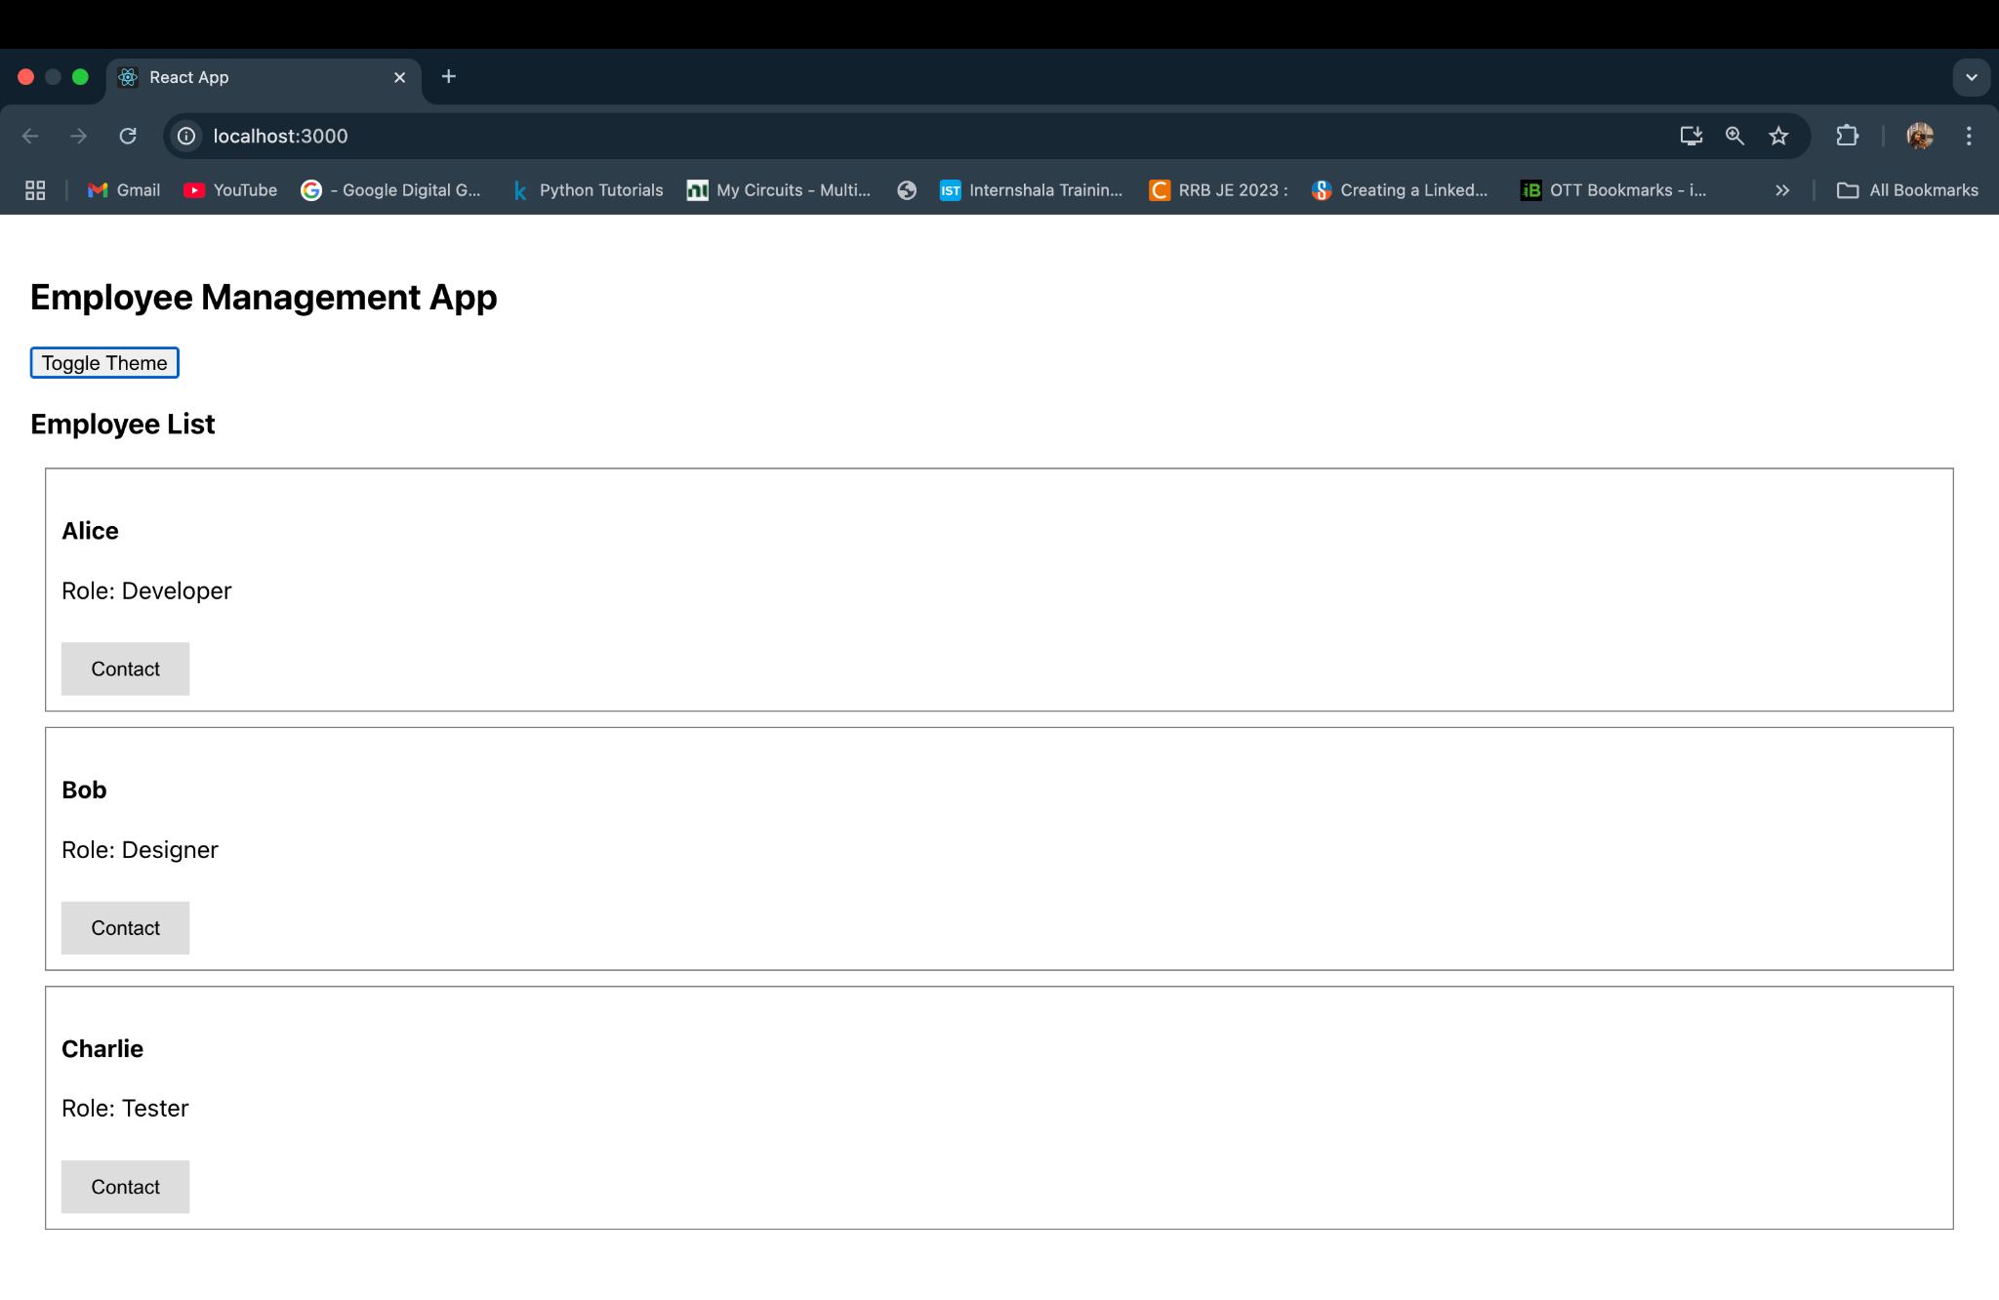
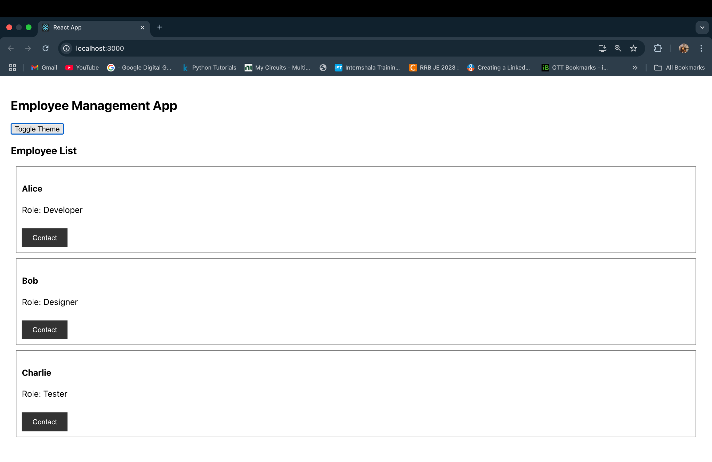
File 15. ReactJS HandsOn
import React, { useState } from 'react';

const ComplaintRegister = () => {
const [employeeName, setEmployeeName] = useState('');
const [complaint, setComplaint] = useState('');

const generateReferenceNumber = () => {
return 'REF-' + Math.floor(100000 + Math.random() * 900000);
};

const handleSubmit = (e) => {
e.preventDefault();
const refNumber = generateReferenceNumber();
alert(`Complaint submitted successfully!\nReference Number: ${refNumber}`);
setEmployeeName('');
setComplaint('');
};

return (
<div style={{ textAlign: 'center', marginTop: '50px' }}>
<h2>Complaint Registration</h2>
<form onSubmit={handleSubmit} style={{ display: 'inline-block', textAlign: 'left' }}>
<div style={{ marginBottom: '10px' }}>
<label>Employee Name:</label><br />
<input
type="text"
value={employeeName}
onChange={(e) => setEmployeeName(e.target.value)}
required
/>
</div>
<div style={{ marginBottom: '10px' }}>
<label>Complaint:</label><br />
<textarea
rows="4"
cols="30"
value={complaint}
onChange={(e) => setComplaint(e.target.value)}
required
/>
</div>
<button type="submit">Submit Complaint</button>
</form>
</div>
);
};
export default ComplaintRegister;
import React from 'react';
import ComplaintRegister from './ComplaintRegister';
function App() {
return (
<div className="App">
<ComplaintRegister />
</div>
);
}
export default App;

Output:

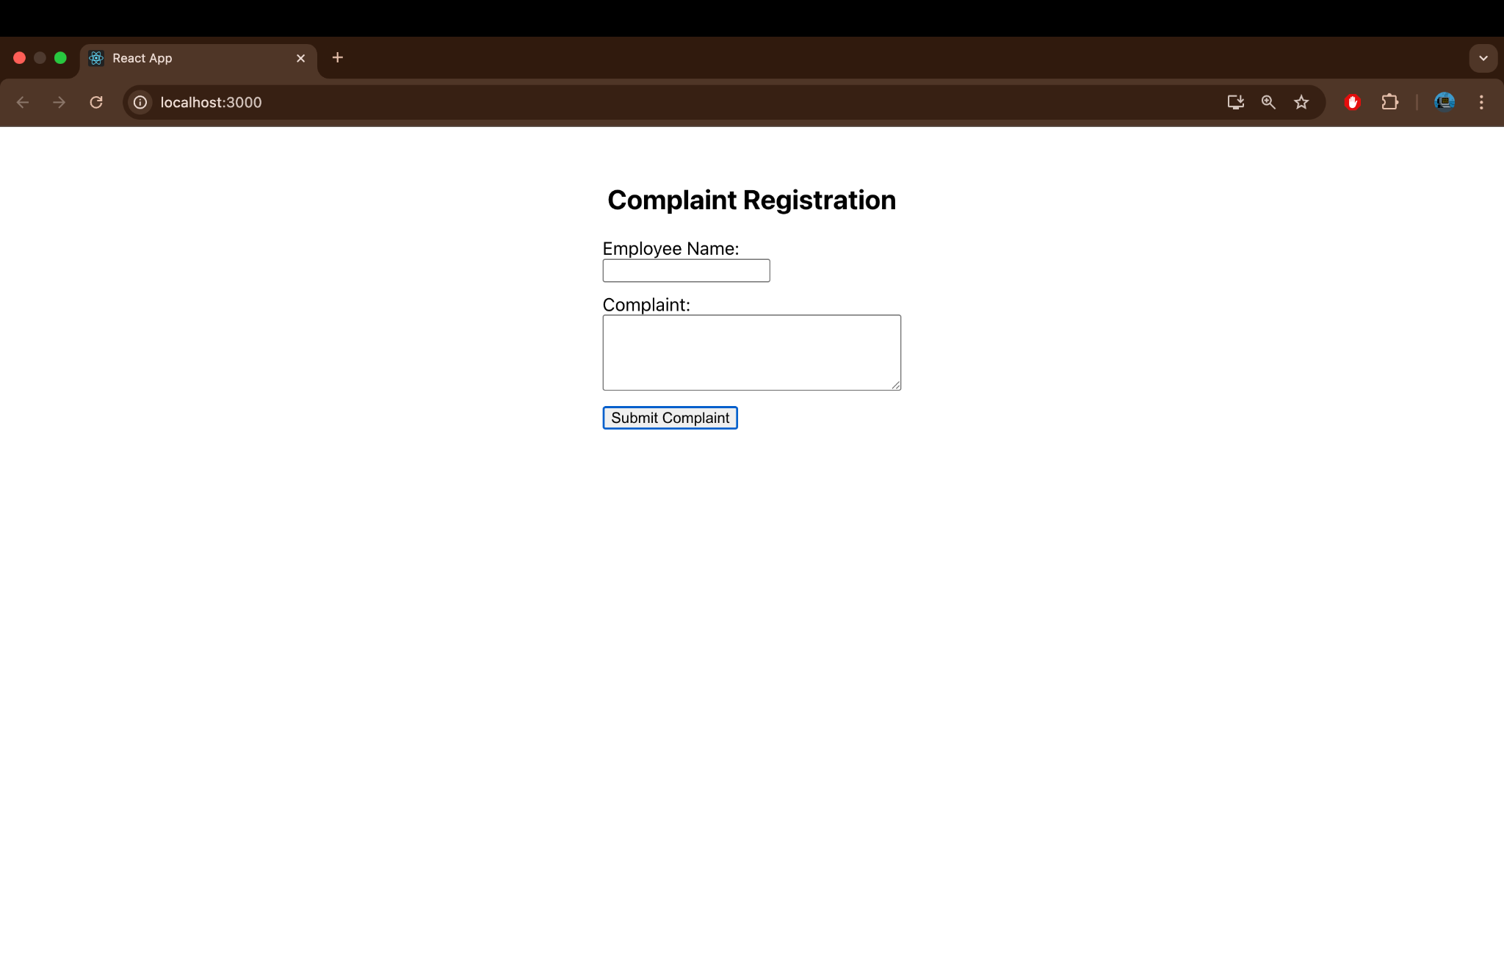

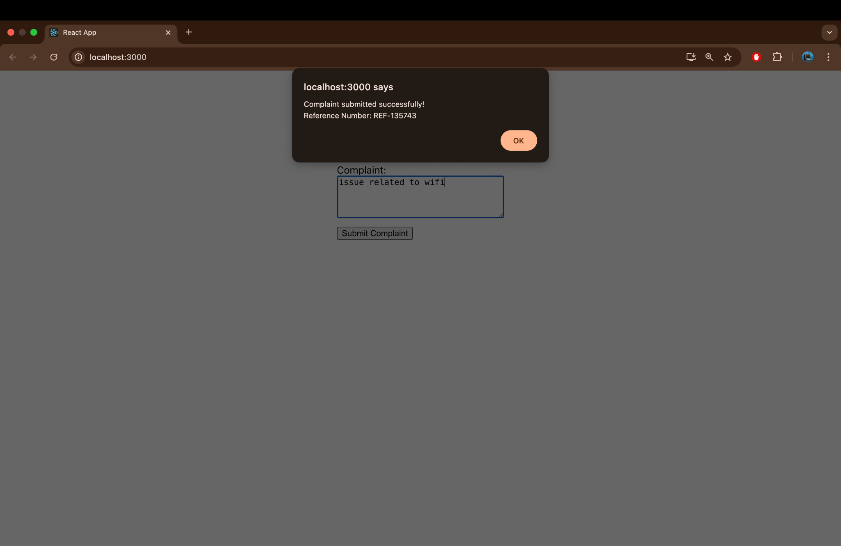

File 16. ReactJS HandsOn
register.js
import React, { useState } from 'react';
const Register = () => {
const [formData, setFormData] = useState({
name: '',
email: '',
password: ''
});

const [errors, setErrors] = useState({});
const handleChange = (e) => {
setFormData({ ...formData, [e.target.name]: e.target.value });
};

const validate = () => {
const newErrors = {};
if (formData.name.length < 5) {
newErrors.name = 'Name must be at least 5 characters long.';
}
if (!formData.email.includes('@') || !formData.email.includes('.')) {
newErrors.email = 'Email must contain "@" and "."';
}
if (formData.password.length < 8) {
newErrors.password = 'Password must be at least 8 characters long.';
}
return newErrors;
};

const handleSubmit = (e) => {
e.preventDefault();
const validationErrors = validate();
if (Object.keys(validationErrors).length === 0) {
alert('Form submitted successfully!');
setFormData({ name: '', email: '', password: '' });
setErrors({});
} else {
setErrors(validationErrors);
}
};

return (
<div style={{ textAlign: 'center', marginTop: '40px' }}>
<h2>Register Form</h2>
<form onSubmit={handleSubmit} style={{ display: 'inline-block', textAlign: 'left' }}>
<div style={{ marginBottom: '10px' }}>
<label>Name: </label><br />
<input type="text" name="name" value={formData.name} onChange={handleChange} />
<div style={{ color: 'red' }}>{errors.name}</div>
</div>

<div style={{ marginBottom: '10px' }}>
<label>Email: </label><br />
<input type="text" name="email" value={formData.email} onChange={handleChange} />
<div style={{ color: 'red' }}>{errors.email}</div>
</div>

<div style={{ marginBottom: '10px' }}>
<label>Password: </label><br />
<input type="password" name="password" value={formData.password} onChange={handleChange} />
<div style={{ color: 'red' }}>{errors.password}</div>
</div>

<button type="submit">Register</button>
</form>
</div>
);
};
export default Register;

App.js
import React from 'react';
import Register from './register';

function App() {
return (
<div className="App">
<Register />
</div>
);
}

export default App;

Output:

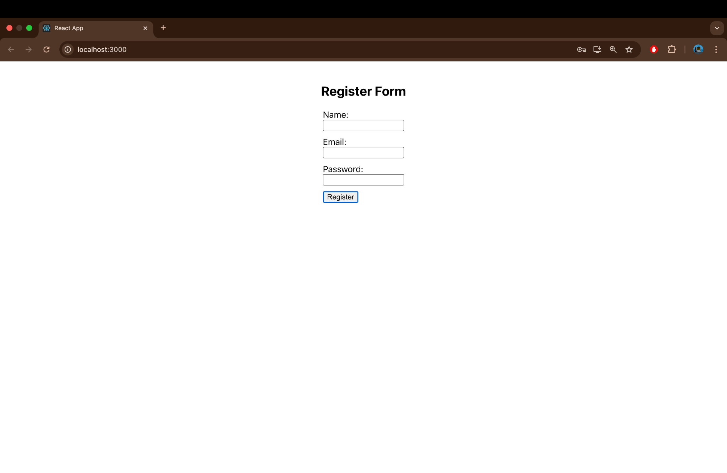

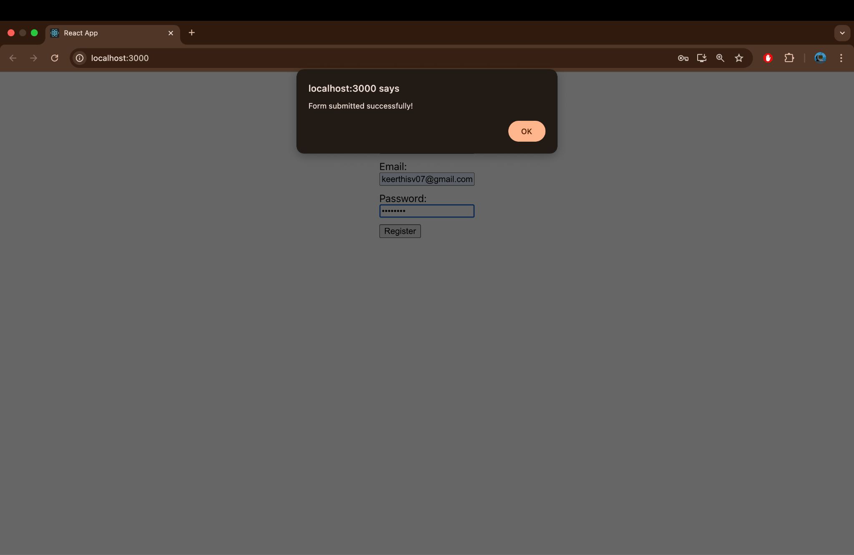

File.17 ReactJS HandsOn
import React, { Component } from 'react';

class Getuser extends Component {
constructor(props) {
super(props);
this.state = {
user: null
};
}
async componentDidMount() {
const response = await fetch('https://api.randomuser.me/');
const data = await response.json();
this.setState({ user: data.results[0] });
}
render() {
const { user } = this.state;
if (!user) {
return <p>Loading user...</p>;
}
return (
<div style={{ textAlign: 'center', marginTop: '40px' }}>
<h2>User Information</h2>
<p>Title: {user.name.title}</p>
<p>First Name: {user.name.first}</p>
<img src={user.picture.large} alt="User" />
</div>
);
}
}
export default Getuser;

import React from 'react';
import Getuser from './Getuser';
function App() {
return (
<div className="App">
<Getuser />
</div>
);
}
export default App;

Output:
